HEALTH & SAFETY

ELECTRONIC VIOLENT INCIDENT REPORTING GUIDE

Contents

1 Introduction 3
2 Accessing the Form 3
3 Completing the Form 4
3.1 Selecting an Option 4
3.2 Create a New Employees Form (Part A) 4
3.2.1 Disclaimer 4
3.2.2 Person Completing the Report 5
3.2.3 Details of the Incident and Person Involved 5
3.2.4 Entering Details of Alleged Assailant(s) 6
3.2.5 Outcome of the Incident 6
3.2.5.1 Injuries 6
3.2.5.2 Damage 6
3.2.6 Manager Identification 6
3.2.7 Incident Report Number 6
3.3 Signing Off a Completed Employee Form 6
4 Completing the Managers Section 7
4.1 Accessing the Managers Form (Part B) 7
4.2 Complete Managers Report 7
4.3 Employees Job Role 7
4.4 Corporate Caution List 7
4.5 Review and Submission of Form 8
4.6 Updating Reports with New Comments or Reviews 8
5 Searching for Reports 8
7 Related Documents 8
8 References 9
9 Support 9
10 Version History 9
Appendix ‘A’ 10

1 Introduction

The electronic violent incident reporting system is replacing the paper based form of reporting violent incidents across the Council in work areas with ready access to computers and the Intranet. For those areas of the council that do not have access to or only have limited access to the Intranet, the paper forms will still be available to report violent incidents.

The benefits of moving towards an electronic form include:

- Streamlining the reporting process;
- Faster notification of managers and the health and safety team to any violent incidents;
- Easier and more accurate reporting on violent incident trends and data;
- The management of actions by utilising e-mail and reminders;
- Reduction in paper usage;
- Easier storage of violent incident data.

2 Accessing the Form

To access the form you must have access to the Intranet. The link to the report form is located on the Intranet – Violent Incident Reporting System.

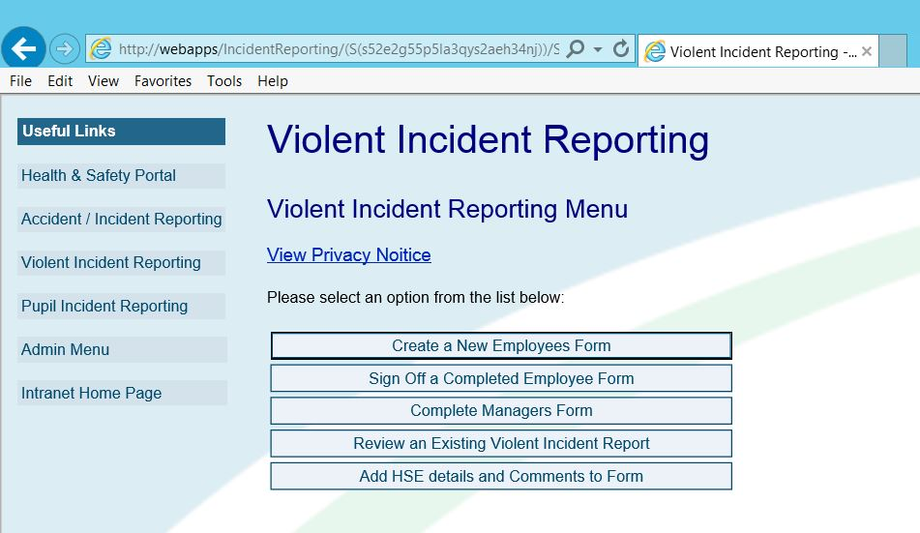

3 Completing the Form

3.1 Selecting an Option

The first page of the report is the main menu which has four options for the user to choose from:

- Create a New Employees Form,
- Sign Off a Completed Employee Form,
- Complete Managers Form,
- Review an Existing Violent Incident Report,
- Add HSE details and Comments to Form.

The option the user selects is determined by what stage of the reporting process they are at and in what capacity they are reporting or viewing the report.

3.2 Create a New Employees Form (Part A)

When users wish to report a Violent Incident, they select the ‘Create a New Employees Form’ option from the main menu.

3.2.1 Disclaimer

When the user chooses to complete a new report, they must tick a box which states that they understand the disclaimer. This is to ensure all users enter accurate data when reporting an accident or incident.

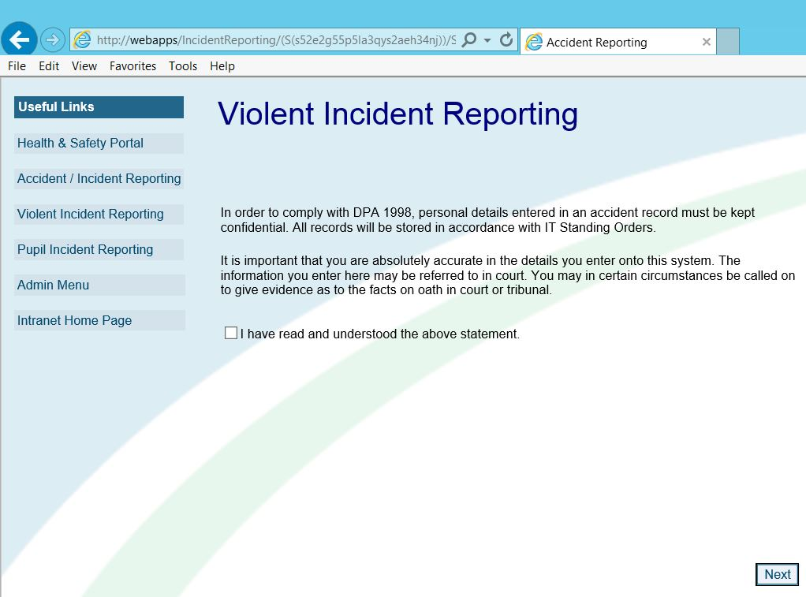

Click here to accept.

Then click “Next”.

3.2.2 Person Completing the Report

If you choose to ‘Create a New Accident/Incident Report’, the first page of the form will require the user to select whether they are completing the form as an employee or as a manager.

For example, if an employee is injured and requires hospitalisation, the manager can complete the accident report on their behalf. For this example, the person completing the form would select ‘Manager’ at this part of the form.
It is important to remember that at all times, all details are entered with as much accuracy as possible.

3.2.3 Details of the Incident and Person Involved

The form will require the user to complete the following basic details:

- Forename
- Surname
- Gender
- Payroll Number
- Directorate
- Department
- Team/Section
- Job Title
- Date of the Incident
- Time of the Incident

Once the user has completed these basic details they are required to enter an account of the incident, providing a clear, factually truthful summary of what happened. In this section the user should include details of any physical or verbal abuse sustained.

The user will then have four options to classify the type of violent incident:

- Verbal Abuse
- Physical Violence
- Threat of Violence
- Sexual Harassment
- Social Media Threat
- Voice Mail Threat
- Vehicle Interference

Once the type of incident has been selected, the form will ask the user if the incident involved any discrimination or police involvement.

3.2.4 Entering Details of Alleged Assailant(s)

To enter the details of an alleged assailant or assailants the user must click the ‘Add Alleged Assailant’ button, and enter all the details they may have about the alleged assailant. Once they have completed all the details they have, the must click ‘Update Assailant’.

3.2.5 Outcome of the Incident

3.2.5.1 Injuries

This section requires the user to enter any injuries which may have resulted from the incident.

3.2.5.2 Damage

This section requires the user to enter any damage to property which may have resulted from the incident.

Finally, this section will ask you to confirm whether the incident resulted in time off work.

3.2.6 Manager Identification

This section requires the user to enter the name of their direct manager. The manager entered in this section will be notified by the system via e-mail of the incident report, and will be responsible for reviewing the incident. Once the manager has been selected the user can submit the form. Schools must use Head in forename and the school name in surname.

3.2.7 Incident Report Number

After the user has submitted the report, they will be given an incident number which they should record for their own reference.

3.3 Signing Off a Completed Employee Form

Once a form has been submitted by an employee, the manager identified in the report will be notified via e-mail advising the manager that a report has been entered by an employee and will provide a link to the report for the manager to review.

Once the manager has reviewed the report they then click on the ‘Sign Off this Form’ button. The manager will now be directed by the system to discuss the incident with the employee involved and complete the manager’s form.

4 Completing the Managers Section

4.1 Accessing the Managers Form (Part B)

The designated manager will receive an email with a link ‘Sign Off a Completed Employee Form’ the manager should click on the link and it will open the Summary Report. The manager should read the report and scroll to the bottom and click on the box marked ‘Sign Off this Report’.

4.2 Complete Managers Report

Another box will appear ‘Complete Managers Report’ and the manager should click in this box. This will open the managers’ report and, if possible, this should be completed jointly with the employee.

4.3 Employees Job Role

The manager should then tick as appropriate on employees’ job role; field, manager or officer. The manager should then enter any outcome(s) of the incident involving time off and / or any additional comments. Any agreed actions taken or to be taken by the manager will then be entered.

4.4 Corporate Caution List

The next box relates to the Corporate Caution list, which is a centrally held list of potentially dangerous residents. Violent warning markers provide a means for identifying and recording individuals in the community who pose, or who could possibly pose, a risk to officers coming into contact with them. If someone is suitable for the list tick ‘yes’ and tick on the incident category as either,

- Other Identified Risk
- Physical Violence
- Sexual Harassment
- Threat of Violence

The manager should enter any ‘comments on health and safety issues’ such as Lone Working, review of risk assessments, etc.

4.5 Review and Submission of Form

A review of the outcome(s) and any action(s) taken should be completed 3-6 months after the incident. A date for review should be selected before checking the ‘submit form’ box.

4.6 Updating Reports with New Comments or Reviews

Any updates after completion will be done by sending an email to the Health and Safety Team, who will enter the information in an additional comments section on the Administrators page.

5 Searching for Reports

To enable the user to search for a particular report within the system there are filter settings in the ‘Review an Existing Violent Incident Report’ section. Under these settings the user can choose from a range of fields to search by:

- Incident Date,
- Date Reported,
- Incident Category,
- Discrimination Category,
- Directorate,
- Department,
- Team/Section,
- Reporter Forename,
- Reporter Surname,
- Payroll Number,
- HSE Notified,
- Eligible for Corporate Caution List,
- Time Off Work,
- Police Involvement, and
- Insurance Claim.

The user will only be able to search and view reports where they are either listed as the injured person, or the nominated manager.

7 Related Documents

- REP-SCH-POL-14.x Violence in a School Setting Policy*

(*Please refer to the Council intranet for the latest version)

8 References

- Health and Safety at Work etc. Act 1974
- The Management of Health and Safety at Work Regulations 1999
- The Reporting of Injuries, Diseases and Dangerous Occurrences Regulations 2013.

9 Support

If you are having trouble with completing the form, contact the Health and Safety Team on ext. 0151 511 7967 or 0151 511 8563

10 Version History

Version Control | Date  Released | Amendment
1 | Jan-2010 | Document created.
2 | Dec-12 | New Intranet Screen Print
3 | Aug-14 | Document reviewed with reference to portal included, minor grammar changes. Major injuries changed to Specified injuries as per RIDDOR 2013. Telephone numbers updated.
4 | Jul-19 | RIDDOR updated to 2013 regulations.  Contact details for H&S team updated.
5 | Jan-22 | Fixed ToC.  Procedures updated – minor changes to wording throughout.  Formatting changes throughout.  Removed ‘Major Injury Types’ (Section 6 in GUI-29.4).  Hyperlinks added throughout.  Updated Appendix ‘A’

Appendix ‘A’

VIOLENT INCIDENT REPORT FORM: GUIDANCE ON COMPLETION

All sections of the forms must be completed and signed by the employee and the manager. A copy should be sent to Risk and Emergency Planning Division (Municipal Buildings) and relevant Operational Director. The employee reporting the incident and their line manager should also keep copies.

Many of the sections for completion are self-explanatory and for that reason are not addressed within this guidance note.

Part A - Create a New Employees Form

Employees should aim to complete this as early as possible after the incident. Consideration should be given to the emotional state of the employee as to whether or not the form filling process should be delayed.

Account of Incident

This should also include as much detail of events leading up to the incident as well as details of the act of violence itself.

Police Involvement

It is recommended within the Violence in a School Setting Policy that acts of physical violence and serious verbal threats are reported to the police. Although this is encouraged, it is dependent upon the employee concerned giving their consent for police involvement.

Where an employee is injured either physically or psychologically as a result of a violent incident they may be entitled to compensation for criminal injuries. It is a pre-requisite for lodging a claim that a crime reference number is obtained along with the attending police officer’s name and number.

Injuries

Describe injuries as precisely as possible, stating which side / region of the body was injured e.g. fracture to right wrist, bruising to lower back, cut above left eye. The Principal Health and Safety Advisor within Risk and Emergency Planning Division will then make a decision on whether there is a requirement to notify the Health and Safety Executive under RIDDOR 2013.

Damage to Property

This includes damage to both council property and employee’s personal property. It is important that details of damage arising from an incident are passed on to the police for the purpose of insurance.

Part B – Accessing the Managers Form

Where possible this part of the form is to be completed by the manager in conjunction with the employee involved. A copy should be sent to Risk and Emergency Planning Division, the relevant Operational Director. Copies should also be retained by both the manager and the employee concerned.

Time off Work

At the time of completing the form it may be difficult to determine the duration of sickness / absence following a violent incident. Managers must note that if a member of staff is off work for more than 7x consecutive days following the date of the incident then Risk and Emergency Planning Division must be notified. The Principal Health and Safety Advisor will then notify the Health and Safety Executive in accordance with RIDDOR 2013. The 7-day period does not include the day of the accident but does include weekends and rest days),

If known, the number of day’s absence should be recorded along with details of the condition resulting in absence e.g. stress or any physical injuries. Where the cause of absence is stress then the guidance in the Emotional Wellbeing Policy must be followed.

Action(s) taken or to be taken by the manager

This section must be completed giving details of any action(s) that the manager may have taken or will take to:

- Provide immediate support to the employee involved,
- Where appropriate, communicate relevant information regarding the incident to other groups of staff,
- Notify the police,
- Write to the assailant stating that the Authority does not tolerate violent incidents and that future occurrences will result in notification to the police,
- Correspondence must be checked by Legal Services before being sent out.
- Revise risk assessment around task / assailant,
- Notify appropriate staff of revised control measures to minimise risk of future occurrences,
- Where appropriate, arrange for the employee to undertake training in dealing with violence and aggression.

Note that any actions identified must be time-bound.

Does the incident meet the criteria for a warning note to be placed on the HBC Corporate Caution List?

The Corporate Caution List (CCL) is on the Intranet and the criteria for a warning note to be placed on the list is:

- Is the offender potentially violent towards other Council staff?
- Are there other environmental risks at the premises e.g. members of the family who are potentially violent, dangerous dogs, squatters, etc.?
- Is there other behaviour at the premises that may pose a risk e.g. alcohol or drugs misuse, sexual harassment?
- Does the offender suffer with potential mental health issues that may pose a risk?

Issues Regarding Lone Working or other Health and Safety Issues

If the incident occurred in a lone working situation, the employee and manager should discuss the lone working procedures in place at the time and establish whether these were properly implemented and whether there is any need for improvement. The lone working risk assessment will need to be reviewed and if necessary improved.

Other health and safety issues may arise; for example the use of an interview room or reception area and the appropriateness of the control measures in place for those environments needs to reviewed to ensure they are sufficient.

Date of Review

Where actions are identified these will need to be reviewed for effectiveness. The manager and the employee should arrange a post-incident review meeting within 3 to 6 months after the incident, or sooner if deemed appropriate.

See Violence in School Settings Policy
See Appendix ‘A’ - Guidance on Completion
See Corporate Caution List Procedures

