HEALTH & SAFETY

Electronic Accident Incident Reporting Guide

1 Introduction 2
2 Accessing the Form 2
3 Completing the Form 3
3.1 Selecting an Option 3
3.2 Creating a New Report 3
3.2.1 Disclaimer 3
3.2.2 Person Completing the Report 3
3.2.3 Injured Party Details 3
3.2.4 Entering the Accident/Incident Details 3
3.2.5 Injury Details 4
3.2.6 Head teacher Identification 4
3.2.7 Adding Comments 4
3.2.8 Attaching Documents 4
3.3 Review an Existing Accident/Incident Report 5
3.4 Close an Existing Accident/Incident Report 5
4 Searching for Reports 5
5 Health and Safety Team Notification 6
6 Specified Injury Types 6
7 Support 7
8 Related Documents 7
9 References 7
10 Version Control and change History 7

Introduction

The electronic accident incident reporting system has replaced the paper based form of reporting injuries and near-misses across the Council in work areas with ready access to computers and the Intranet. For those areas of the council that do not have access or only have limited acces to the Intranet, the paper forms will still be available to report injuries and near-misses.

The benefits of moving to an electronic form include:

- Streamlining the accident reporting process;
- Faster notifcation of managers and the health and safety team to accidents or incidents;
- Easier and more accurate reporting on injury trends and data;
- The management of actions by utlising e-mail and reminders;
- Reduction in paper usage;
- Easier storage of accident and incident data.

Accessing the Form

To access the system you must have access to the Intranet. The link to the system is located on the Intranet home page under ‘My Job’ using the ‘Health & Safety and Risk Management Portal.

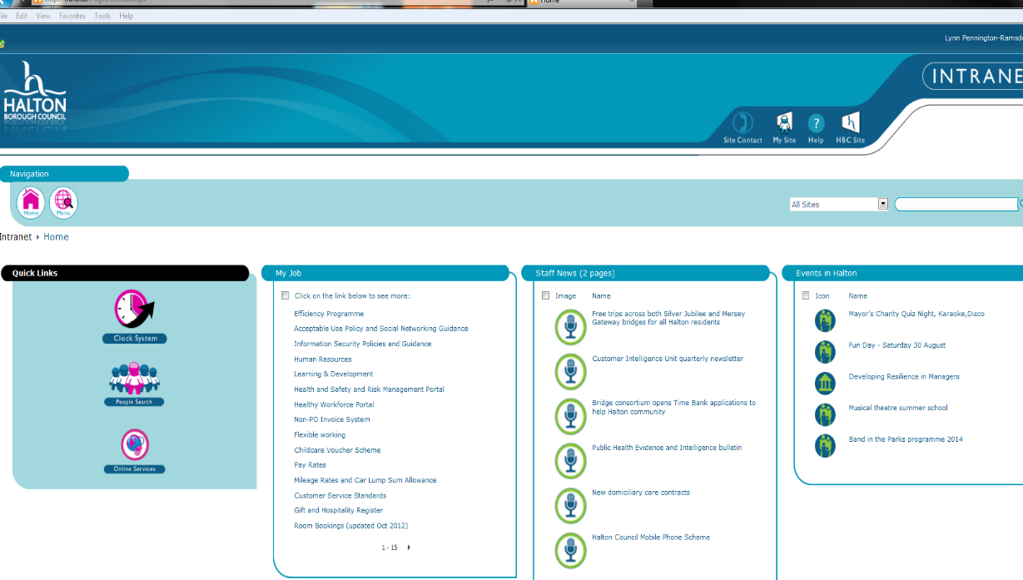

You will be required to choose between either Accident or Violent Incident reporting. Select Accident reporting.

Completing the Form

Selecting an Option

The first page of the report is the ‘Main Menu’ and will have three options for the user to choose:

- Create a New Accident/Incident Report;
- Review an Existing Accident/Incident Report;
- Close an Existing Accident/Incident Report.

The option the user selects is determined by what stage of the reporting process they are at and what capacity they are reporting or viewing the report.

Creating a New Report

Disclaimer

When the user chooses to complete a new report, they must tick a box which states that they understand the disclaimer. This is to ensure all users enter accurate data when reporting an accident or incident.

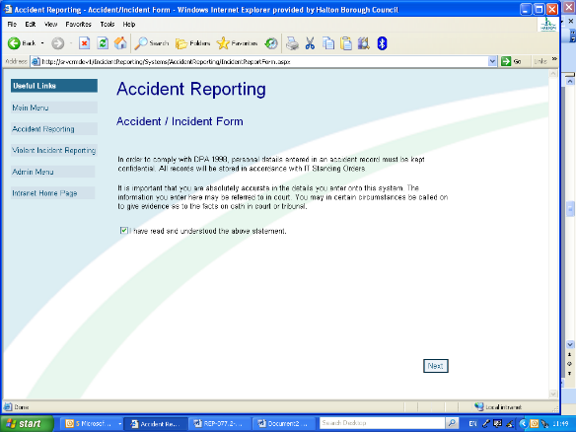

Person Completing the Report

If you choose to ‘Create a New Accident/Incident Report’, the first page of the form will require the user to select whether they are completing the form as an employee or as a Head teacher.

For example, if an employee is injured and requires hospitalisation, the Head teacher can complete the accident report on their behalf. For this example, the person copmpleting the form would select ‘Manager’ at this part of the form.
Action: Head teachers will have to identify how and who will be responsible for completing initial reports.

Injured Party Details

Once the user has chosen either ’Employee’ or ‘Manager’ and clicked the ‘Next’ button, they must enter the details of the injured person. If the incident is a near-miss and did not result in an injury, the user simply selects ‘Near Miss’ from the drop-down menu and enters their own details.

Entering the Accident/Incident Details

Once the injured person details have been entered over 2 pages including their own home address, telephone numbers etc, the next page of the form requires the details of the accident/incident.

This section of the form requires the following information:

- Date of the accident;
- Time of the accident;
- Location of the accident;
- The accident category;
- A brief description of the accident.

Injury Details

Once the details of the accident/incident have been entered, any injury details must be entered ticked in the respective box in the grid. Further information can then be entered in boxes for:

- Any further injury details;
- Whether the injury has incurred time off work;
- Details of first aid administered;
- Any witnesses present at the time of injury.

Please note if no injury details are entered then it will be recorded as ‘no injuries’.

Under this section there is also a witness statement template available if required.

Manager Identification

Once the details of the injuries have been entered and the user has clicked ‘Next’, the form requires the selection of a manager for the report to be sent to for review. The user simply enters the name of the Head teacher/manager they wish to have the report sent to and clicks ‘Search’. There can be different Head teachers/managers identified for different reports depending on the nature of the report or the availability of the Head teacher/manager.

For school searches enter Head into the forename search and the school name into the surname search. Click ‘select’ on the appropriate name.

Adding Comments

The user can add comments in this section of the report. When the report is being reviewed by the nominated Head teacher/manager, they too can add comments in this section. Head teachers/managers can also add comments after they have closed the report if more information becomes available in future relating to the accident or incident.

Attaching Documents

The user, Head teacher/manager or administrator can attach documents to a report. Documents may be anything that is relevant to the accident/incident report, including, but not limited to:

- Photos of the injury or scene of the accident
- Maintenance records
- Training records
- Inspection reports
- Qualifications/Licences
- Witness Statements
- Risk assessments
- Safe Systems of Work
- Emergency Services Reports (Fire Brigade, Ambulance etc.)
- E-mail correspondence relating to the accident

Review an Existing Accident/Incident Report

If the user chooses to ‘Review an Existing Accident/Incident Report’ they simply select this option from the ‘Main Menu’. Once they have selected this option, they are able to view any report from the list by clicking ‘View Report’ or view a summary of the report by clicking ‘View Summary’. The user cannot modify any of the reports details.

The user can add comments at the end of the report which may include:

- New information from an investigation;
- A change in the amount of time off work for the injured person;
- Any updates on the injured persons injury.

A user will only be able to access and view the reports that they are listed as either the employee or manager in the report.

Close an Existing Accident/Incident Report

When a report has been finalised and no longer requires any input, the Head teacher/manager may close the report. If the Head teacher/manager chooses to ‘Close an Existing Accident/Incident Report’ they simply select this option from the ‘Main Menu’. Once they have selected this option, they are able to close any report from the list by clicking ‘Close Report’. This option is only available to the nominated Head teacher/manager in the report.

Searching for Reports

As the system grows, more and more reports will be stored on the system. To enable the user to search for a particular report within the system there are filter settings in the ‘Review an Existing Accident/Incident Report’ section. Under these settings the user can choose from a range of fields to search by:

- Date Reported
- Open/Closed (Status)
- Incident Date
- Incident Category
- Injured Party Type
- Injured Party Forename
- Injured Party Surname
- Directorate
- Department
- Section
- HSE Notified?
- Level of Incident

The filters will search all available reports by the criteria selected by the user. The user will only be able to search and view reports where they are either listed as the injured person, or the nominated Head teacher/manager.

Health and Safety Team Notification

Under the paper based accident reporting system, when an accident/incident report is filled out the paper form is sent to the health and safety team. For areas of the Council without ready access to the Intranet this will remain the same.

For users of the electronic system, when you submit your report it is sent to the health and safety team as well as the nominated manager via e-mail. This allows the health and safety team to monitor the accidents/incidents that are occurring across the Council and offer advice or guidance as necessary.

In the event of a fatality or a major accident involving the types of specified injuries listed in Section 6, the health and safety team should be notified immediately on 0151 511 7967 or 0151 511 8563.

Specified Injury Types

The following types of injuries are classified as specified under the Reporting of Injuries, Diseases & Dangerous Occurances Regulations (RIDDOR) 2013:

- Fractures, other than to fingers, thumbs and toes
- Amputation of an arm, hand, finger, thumb, leg, foot or toe
- Any injury likely to lead to permanent loss of sight or reduction in sight in one or both eyes
- Any crush injury to the head or torso, causing damage to the brain or internal organs
- Any burn injury (including scalding) Which: covers more than 10% of the whole body’s total surface area or causes significant damage to the eyes, respiratory system or other vital organs
- Any degree of scalping requiring hospital treatment
- Any loss of consciousness caused by head injury or asphyxia
- Any other injury arising from working in an enclosed space

Support

If you are having trouble completing the form, contact the health and safety team on 0151 511 7967 or 0151 511 8563.

Related Documents

- Accident/Incident Reporting Policy
- Accident/Incident Investigation Checklist Guidelines
- Accident/Incident Report Form

References

- The Health and Safety at Work etc. Act 1974
- The Management of Health and Safety at Work Regulations 1999
- Reporting of Injuries, Diseases and Dangerous Occurances Regulations 2013.

Version Control and change History

Version Control | Date  Released | Amendment
1 | Jan-2010 | Document created.
2 | Aug-2011 | Document reviewed with minor changes
3 | Aug-2014 | Document reviewed. Access to system updated. Witness statement template included. Managers changed to and/or Head teachers. Telephone numbers updated. Major injuries changed to specified as per RIDDOR changes 2013 regulations. Injury categories updated.
4 | July 2019 | Document reviewed, telephone numbers updated.

